Answer all the following questions in “one word document named properly to reflect your name + course code with section + week of the course + file contents”.

🡺 Please keep only these portions of the document with your answers.  
 **Kindly delete the instructions and notes.   
 −20% cost if you make me wade through the stuff I asked you delete.**

**Part 1: Compression (40 points) using Notepad++**

* For this activity, we will be exploring file compression.   
  The total text of this nursery rhyme is   
  187 characters including a trailing space after each word:

**the itsy bitsy spider crawled up the water spout**

**down came the rain and washed the spider out**

**out came the sun and dried up all the rain**

**and the itsy bitsy spider went up the spout again**

Copy the rhyme to Notepad++.

Notepad++ menu: TextFX Tools, Word Count should show 187 characters.

(TextFX, if not present, can be installed with a few clicks: Plugins menu item -> Plugin Manager -> Show Plugin Manager -> select TextFX Characters and click install. Restart Notepad++. Sometimes, you need to do this process twice to make it work.)

**Using the token/string substitution dictionary ideas in the lecture notes,   
how much can you compress the text?**

* Use digits and/or the special characters on the shifted top row for tokens: **1234567890!@#$%^&*()_+**
* Do not use a separator in the token/string dictionary entries. e.g. **\*the**
* Copy & Paste into this document:  
  🡺 your dictionary of token/string characters, one entry per line.  
  🡺 rhyme with the token substitutions, i.e. the compressed text  
  🡺 how many characters are in the dictionary + compressed text and what is it as percentage of the original’s 187?

This may help with your analysis:

* copy the rhyme to another new document
* replace each space with a space + new line   
  (Notepad++ menu: Search / Replace… See Replace dialog below.)
* sort the lines to see repeating words. Notepad++ menu: TextFX Tools, Sort

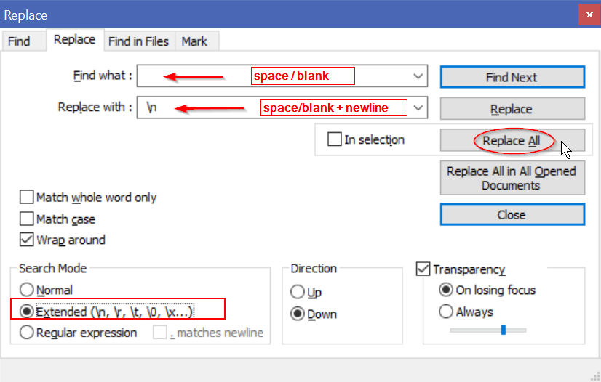

For the ***length*** of any string occurring ***n*** times and replaced by a single character token:

Saving ***n*** occurrences * ***length*** costs the dictionary entry (token char + ***length***) plus the ***n*** token placeholders in the data stream.

e.g. "the " occurs 8 times with a length of 4 including the trailing space (32 characters)  
less the compression overhead of a 5 char dictionary entry + 8 tokens (13 characters)  
is 32 original less 13 overhead = 19 characters saved.

Anything occurring only once is not worth substituting with a token and including in the dictionary; you will just be adding two characters (the tokens) to the file. Anything with a length of 2 or 3 and occurring only twice is similarly not worth it.

Here is an example of saving many characters with two repeating words (the, and) replaced by tokens (#,@) along with the dictionary entries:

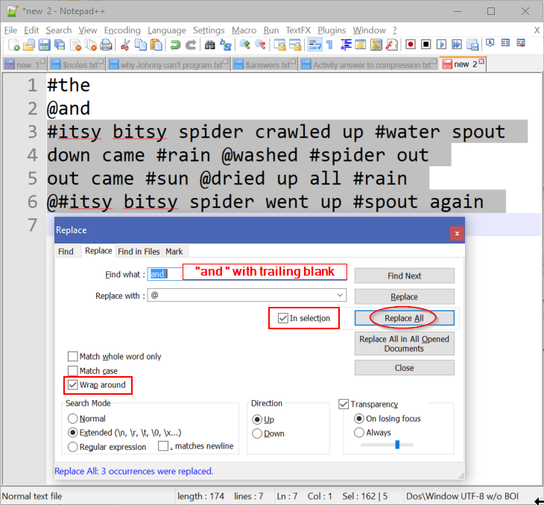

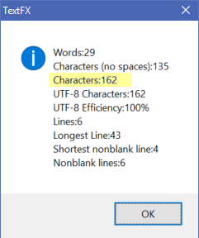

To check the resulting length of the dictionary + compressed text, select all the text and  
Notepad++ menu: TextFX Tools, Word Count

(The length shown on the bottom status line of 174 includes all file characters including the hidden CRLF ‘new line’ characters. We are not considering those in our compression.)

**Part 2:** For this part of the activity, complete the following:

* Create a directory on your Desktop, it can be any name you like.
* Download the following files from Blackboard to the directory.
  + macaw.gif
  + macaw.bmp
  + macaw.jpg
* Download this week’s PowerPoint slides, open it, and Save As, PDF (*.pdf)
* Save this week’s PowerPoint slides to: Save As , Outline/RTF (*.rtf)
* Put this Word document into that same directory.

Compress all files into a zip file archive: select the files then right click and use the S*end to* > *Compressed (zipped) folder* option or use 7zip.

Open the .zip file with Windows Explorer.   
Use the Snipping Tool ( + “snip”) to copy only the information seen below.

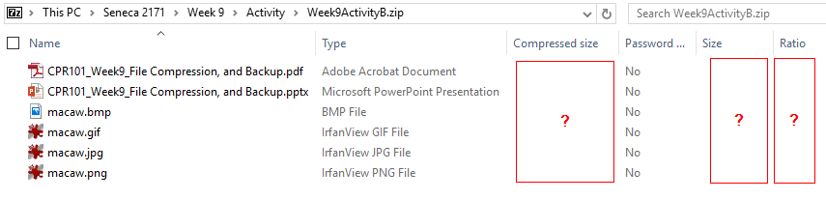

The compression ratio is (1 – compressed/original size) showing the space saved by the zipping, i.e. compressing, the original files into the archive.

FYI: opening the .zip file with 7zip will show exact bytes for original Size and Packed (compressed) size. 7zip does not show the compression ratio.

Paste the image of the Windows Explorer .zip file information here…

Use the Snipping Tool ( + “snip”) to copy only the information seen above.

**🡺**

What do the compression ratio percentages tell you about the contents of the different kinds of files? Were some of the files already compressed in their original format before zipping tried to compress them further? Which files do you think were already compressed? **(10 points)****🡺**

The files with high Ratios were compressed the most. Which files were they? Why were they compressed the most? **(10 points)**See <https://www.noupe.com/design/everything-you-need-to-know-about-image-compression.html>   
**🡺**

**Part 3: Backup**

* In order to preserve important information, you must make a copy and store if off of your laptop, or PC. One option would be to store your data, somewhere on your college’s network. To practice this, use the content area of Blackboard.
  1. Login to Blackboard
  2. Click on the Content System tab near the top right
     1. You may need to click on Users and click on your name
  3. From the menu under “My Content”, click on Create Folder
  4. Name the folder CPR101_Activities and click Submit
  5. Click on the new folder to open it up
  6. Select Upload, then Upload Files from the menu  
     

You can upload one file at a time or all the files contained in a Zip file.  
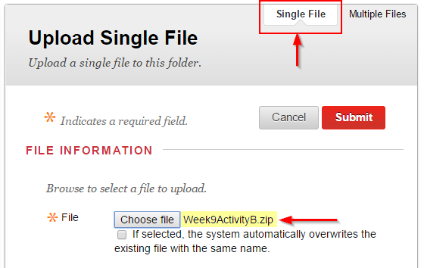

* 1. Browse your CPR101 files upload something to the folder, e.g. the zip file you created in Section B…being compressed and a single upload, it would take the minimum amount of time.

🡺 paste a screen shot of your backup results. (Alt-PrtScn or use the Snipping Tool) **(10 points)**

**Imagine your laptop just went up in smoke/melted down/destroyed itself** after you completed a great many hours of work today and yesterday. What is (or what should have been) your backup & restore strategy? How does your strategy address the 3 characteristics of a real backup? How does your strategy fulfill the 3-2-1 backup check? Replacing a machine is more than just restoring your lost data files. What about the Operating System and the applications which process those files? How long would this all take…and what if you a had a big assignment due tomorrow? **(30 points)**🡺